**Beth EI Temple**

March 2018 Adar-Nisan 5778

Dear Friends,

We best promote Jewish life by engaging in acts of memory and building. With the coming of spring, we are given the opportunity to recall the six million who died at the hands of the Nazis in the Holocaust with the observance of *Yom HaShoah.* This year the commemoration begins on Wednesday evening, April 11th.

I hope that you will pause, remember the dead and mark the beauty of their lives by kindling the yellow candle on that evening. It is provided by our Beth El Men's Club as part of the international campaign on the part of the Federation of Jewish Men's Clubs. In kindling this light, pausing and remembering them, we ensure that those we have lost will forever have a place in our hearts and lives.

During the Holocaust, the Nazis and their collaborators murdered over 1.5 million Jewish children under the age of 16. This year, the Men's Club hopes to personalize your family's observance of *Yom HaShoah* by providing each Beth El family with the name and homeland of a young victim who may have no surviving relatives to light a candle in his or her memory.

Our Men's Club contributes the proceeds from the *Yom Hashoah* Candle Project support the Temples Camp Ramah Scholarship Fund. I hope that you will join with me in making a contribution of any amount to the Temple's Camp Ramah Scholarship Fund. By fostering Jewish identity among today's Jewish youngsters through a meaningful camping experience, we honor the memory of those who had little chance to know the beauty of Jewish life. Your generous donation will ensure that the future will be led by those who have had the opportunity to embrace all that Jewish life has to offer.

With thanks to our Men's Club for spearheading this effort, I also wish you the very best.

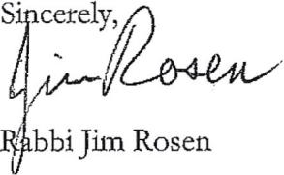

Donations should be made out to "Beth El Men's Club"

Online Donations: tiny.cc/YellowCandles

2626 Albany Avenue West Hartford, CT 06117 Phone: 860.233.9696 BethEIWestHartford.org