 

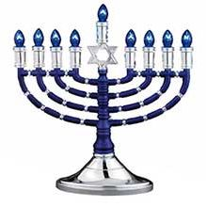

**TRZ Men’s Club Presents**

**Menorahs and Martinis**

Monday, December 18, 2017

7:30 PM

Social Hall

$13 per person

Enjoy

Falafels, Donuts, Chips/Salsa/Drinks

RSVP by

Friday, December 15 at 2:00 PM

Mario Avendano

lejaim18@gmail.com