The Kol Rinah Brotherhood Leo Wolf Yellow Candle Program
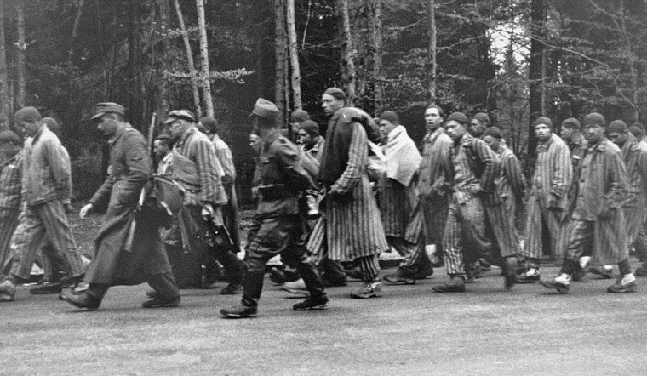
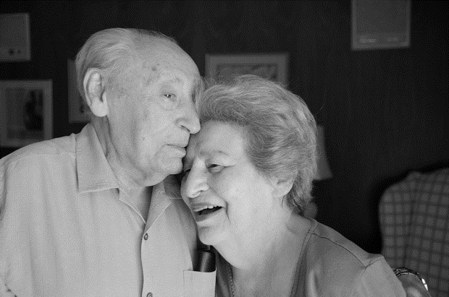
Leo had three passions, his family (Robert z’’l, Harvey and Michael and all their wives and children and grandchildren), educating people about the Holocaust and the State of Israel.
The Yellow Candle program plays a strong part in supporting the Kol Rinah Brotherhood’s Rabbi Emeritus Youth Scholarship Fund, which helps send our Kol Rinah youth to programs in Israel. The linkage of remembering the Holocaust and supporting Israel is why our Brotherhood unanimously decided to rename this program in honor of Leo Wolf’s memory.
Please help us remember those who suffered in the Holocaust along with the memory of Leo Wolf by lighting a Yellow Candle with Kol Rinah, St. Louis and people around the world on the evening of Yom HaShoah, on sundown of Wednesday, April 7, ending at sundown on Thursday, April 8, ‒ the day dedicated to remembering the Holocaust.
Your contributions to the Leo Wolf Memorial Candle program will be greatly appreciated.
Leo found Sara, the love of his life, in a Displaced Persons camp (she was a sister of a childhood friend), and they came together to the St. Louis area without a dollar in their pockets.
Leo built a successful construction business in Illinois and became a philanthropist supporting Shaare Zedek and later Kol Rinah. He was one of the co-founders of the St. Louis Holocaust Museum.
Leo Wolf, partially hidden fifth from right, was a survivor of the Łódź Ghetto, Dachau, Auschwitz and 10 other concentration camps. His will to live was so strong, he escaped this death march and managed to survive. When he was liberated by the Americans, he weighed just 66 pounds.

