**Kristallnacht**

* http://accountsoftheholocaust.org/accountsoftheholocaust/media/Avatars/ruth-cardin.jpg?ext=.jpgRUTH CARDIN

November 13, 1938

*What’s been happening the last couple of nights? I heard that Jewish shops and homes have had windows smashed and that the contents have been looted? Is everyone OK?*

http://accountsoftheholocaust.org/accountsoftheholocaust/media/Avatars/miriam-shapiro.jpg?ext=.jpgMIRIAM SHAPIRO (Leipzig, Germany. 14 years old)

What happened on the 9th of November in the evening I don't know, but in the morning I wanted to go back to school. My father told me not to go to school. We had 17 synagogues in Leipzig and my father wanted to go to pray in the morning, but everyone said, "Don't go, don't go – the synagogues are all burning – there are no synagogues anymore."

http://accountsoftheholocaust.org/accountsoftheholocaust/media/Avatars/arnold-goldschmidt.jpg?ext=.jpgARNOLD GOLDSCHMIDT (Fulda, Germany. 16 years old)

all of a sudden Nazis came and ransacked our apartment, threw everything down, the silver, the gold and threw it out the window… The people from our building who we were friendly with, people that we knew for 20-30 years were standing outside our window catching it. Imagine how we felt

http://accountsoftheholocaust.org/accountsoftheholocaust/media/Avatars/herbert-mai.png?ext=.pngHERBERT MAI (Wurzburg, Germany. 9 years old)

We heard banging and hollering and screaming for about what seemed like hours. And then it stopped and we thought it was safe to go downstairs. And when we came downstairs, our whole business, all the windows were broken, all the tools were strewn over the floor and all the benches were broken up and in our apartment, every chair and every sofa and every bed was cut open with a knife.

http://accountsoftheholocaust.org/accountsoftheholocaust/media/Avatars/FRITZ-GLUCK.jpg?ext=.jpgFRITZ GLUCKSTEIN (Berlin, Germany. 11 years old)

 I walked to school… and first store broken windows and I said well maybe an accident, who knows? And a little bit further, there was another one. Well that was strange. And with the third store I realised that something had happened. And then walking to school I saw… the windows of the Jewish stores broken and I saw already at a distance the smoke. First I didn’t know what it meant, but then I realised, they are burning the synagogues.

http://accountsoftheholocaust.org/accountsoftheholocaust/media/Avatars/miriam-shapiro.jpg?ext=.jpgMIRIAM SHAPIRO

I saw a piano being thrown out of the window of an apartment next to us.

http://accountsoftheholocaust.org/accountsoftheholocaust/media/Avatars/Ruth_Andreas-friedrich.jpg?ext=.jpgRUTH ANDREAS-FRIEDLICH (Berlin, Germany)

The Kurfurstendamm is a sea of broken glass.

* http://accountsoftheholocaust.org/accountsoftheholocaust/media/Avatars/ruth-cardin.jpg?ext=.jpgRUTH CARDIN

*A friend just sent me this photograph of burnt Torah scrolls from Worms in Germany*  
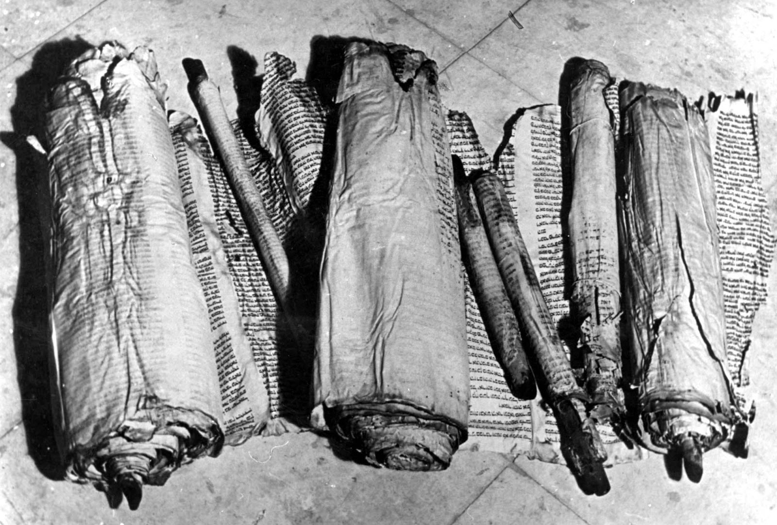

http://accountsoftheholocaust.org/accountsoftheholocaust/media/Avatars/johanna-gerechter.jpg?ext=.jpgJOHANNA GERECHTER (Hamburg, Germany)

When we Jews talk about our Torah scrolls, this is the basis of our beliefs. This is the basis of our observance. This is the basis of our lives. This was thrown into the street. It was torn up. I was desecrated by hordes of people who had absolutely lost all respect of any other people’s religion. It works itself right into the fact that you hate for the sake of hating; but you really don’t know why you are hating.

http://accountsoftheholocaust.org/accountsoftheholocaust/media/Avatars/ruth-cardin.jpg?ext=.jpgRUTH CARDIN

*Didn’t anyone stop to help?*

http://accountsoftheholocaust.org/accountsoftheholocaust/media/Avatars/arnold-goldschmidt.jpg?ext=.jpgARNOLD GOLDSCHMIDT

Help? We had a Catholic home across the street from our business. When we knocked on the door… they refused to open for us. They were always friendly before. “We will not help you, we cannot help you, we won’t do anything for you.”

http://accountsoftheholocaust.org/accountsoftheholocaust/media/Avatars/44581.jpg?ext=.jpgHEDI POLITZER (Vienna, Austria. 18 years old)

There were some very good people too, that gave you some phone calls to say we are sorry about all this; are you all right?

http://accountsoftheholocaust.org/accountsoftheholocaust/media/Avatars/miriam-shapiro.jpg?ext=.jpgMIRIAM SHAPIRO

One of our non-Jewish neighbours shouted, “Run, run Jews, you can run to the Dead Sea and drown there”

http://accountsoftheholocaust.org/accountsoftheholocaust/media/Avatars/marga-randall.jpg?ext=.jpgMARGA RANDALL (Schermbeck, Germany. 8 years old)

My grandparents did go next door. The Christian family opened their door and took them in, gave them breakfast.

http://accountsoftheholocaust.org/accountsoftheholocaust/media/Avatars/miriam-shapiro.jpg?ext=.jpgMIRIAM SHAPIRO

Another taxi came and my father said, "Do me a favor, take us somewhere." He said, "Come in – come in, I am so happy to do something against these damned Nazis." When my father asked why he was helping us, he said all his family was in a concentration camp because they were Communists. "I am so pleased to help you." He told us he had passed by the Polish consulate and seen a large crowd of Jews hiding there, even in the garden. They had Polish passports so they had diplomatic immunity and were theoretically on Polish soil.

http://accountsoftheholocaust.org/accountsoftheholocaust/media/Avatars/hillel.jpg?ext=.jpgHILLEL SCHECHTER

We sat in the apartment for three days. We heard a knock at the door. The knocking continued and someone called out my sister’s name. It was one of the employees of the firm she worked for, a non-Jewish accountant. He knew her address and came at night to see how we were and if he could help. This was an extraordinary man. He promised to bring us bread and some food.

* http://accountsoftheholocaust.org/accountsoftheholocaust/media/Avatars/ruth-cardin.jpg?ext=.jpgRUTH CARDIN

*I have heard that these attacks were in response to the assassination Ernst vom Rath at the German Embassy in Paris? Do you think that these attacks have been spontaneous outbursts of anger?*

http://accountsoftheholocaust.org/accountsoftheholocaust/media/Avatars/marga-randall.jpg?ext=.jpgMARGA RANDALL

This was so highly organised. The Nazis from Brunnen came to Schermbeck to destroy the homes of the Jews and our synagogue. The Nazis from Schermbeck went to Dorsten to do their damage. It seems that it is easier to hurt someone you don’t know.

http://accountsoftheholocaust.org/accountsoftheholocaust/media/Avatars/gerald-liebenau.jpg?ext=.jpgGERALD LIEBENAU

No one tried to put out the fire. Now that’s not possible unless it’s well-planned and orders had gone out to every fire station in Germany that when the synagogue was aflame, you do not put out the fire.

http://accountsoftheholocaust.org/accountsoftheholocaust/media/Avatars/firefighter.png?ext=.pngFIREFIGHTER (ANONYMOUS)

I was not allowed to go into the firehouse to take the engines out, or even to open the doors. One of my friends, who lived next to the Synagogue, whispered to me, "Be quiet - the Synagogue is burning; I was beaten up already when I wanted to put out the fire."

http://accountsoftheholocaust.org/accountsoftheholocaust/media/Avatars/gerald-liebenau.jpg?ext=.jpgGERALD LIEBENAU

That’s so much against the nature of a fireman—I don’t care what his nationality is—that it had to be a very stern order, and there were undoubtedly Gestapo people all around making sure that this was going to be done that way

http://accountsoftheholocaust.org/accountsoftheholocaust/media/Avatars/firefighter.png?ext=.pngFIREFIGHTER (ANONYMOUS)

We had to stand watch at the Synagogue to make sure there were no more smoldering sparks. My turn was from 10-11 and 2-3 P.M. The brown uniforms paraded around to admire their work.

* http://accountsoftheholocaust.org/accountsoftheholocaust/media/Avatars/firefighter.png?ext=.pngFIREFIGHTER (ANONYMOUS)

As I was watching the destroyed Synagogue and the frail old Jews, I wondered whose turn would be next!... When would it be our turn? Will the same thing happen to our Protestant and Catholic Churches!

* http://accountsoftheholocaust.org/accountsoftheholocaust/media/Avatars/Ruth_Andreas-friedrich.jpg?ext=.jpgRUTH ANDREAS-FRIEDLICH

We all sit here on the bus ready to die of shame. Brothers in shame; comrades in humiliation. But if everyone is ashamed, who smashed those windows?

* http://accountsoftheholocaust.org/accountsoftheholocaust/media/Avatars/ruth-cardin.jpg?ext=.jpgRUTH CARDIN

November 14, 1938

*Maybe someone in this group can help locate the owner.  This black velvet tefillin pouch, embroidered with the initials B G was found thrown into the street in Forchheim, Germany.  A friend sent this photo to me - he thinks it might belong to one of his neighbours Bernhard Groeschel? If anyone know where he or his wife Rose are, please let me know so that it can be returned.*  
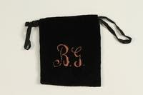

* http://accountsoftheholocaust.org/accountsoftheholocaust/media/Avatars/ruth-cardin.jpg?ext=.jpgRUTH CARDIN

*What now? What next?*

http://accountsoftheholocaust.org/accountsoftheholocaust/media/Avatars/miriam-shapiro.jpg?ext=.jpgMIRIAM SHAPIRO

My piano teacher came to tell us that all the German Jewish men including her husband were sent to concentration camps.

http://accountsoftheholocaust.org/accountsoftheholocaust/media/Avatars/FRITZ-GLUCK.jpg?ext=.jpgFRITZ GLUCKSTEIN

Some of the teachers didn’t appear because at random they took Jewish men and sent them to concentration camps.

http://accountsoftheholocaust.org/accountsoftheholocaust/media/Avatars/44581.jpg?ext=.jpgHEDI POLITZER

(My father) just didn’t come home on… November 10th. No phone call, no anything…. And what puzzles me very much, because my father had been in the war. He was in World War I. He was not a hero or anything, but he had served in the military.

* http://accountsoftheholocaust.org/accountsoftheholocaust/media/Avatars/margarete-drexler.jpg?ext=.jpgMARGARETE DREXLER

The sum of 900 Marks in cash was confiscated from me in the course of the action of 10th November… I need it urgently for me and my child’s livelihood… as my husband died as a result of his injuries during the war – he fought for his fatherland with extreme courage – and I am left without and income.

* http://accountsoftheholocaust.org/accountsoftheholocaust/media/Avatars/robert-katz.jpg?ext=.jpgROBERT KATZ

November 15, 1938

*I’ve been sent an extract from a report by Diechhoffe, the German Ambassador in Washington. I thought members of this group would find it interesting:   
“The recent events are the best thing that could have happened to the Jews and the worst thing that could have happened to Germany because they arouse universal sympathy.”*

http://accountsoftheholocaust.org/accountsoftheholocaust/media/Avatars/kurt-klein.jpg?ext=.jpgKURT KLEIN (Buffalo, USA)

The first inkling any of us had of Kristallnacht was of course the brief articles we read in the daily press here in the US. But eventually some letters reached us that attempted to brief us, to some extent, to what had happened that night. I found out… that a gang of SA Storm Troopers invaded my parent’s home that night and they were led by a former classmate of mine who had been in and out of our home, who had eaten at our table and at who’s house I had spent some time.