**Liberation**

[Previous Posts](http://accountsoftheholocaust.org/War-Years.aspx)

* http://accountsoftheholocaust.org/accountsoftheholocaust/media/Avatars/robert-katz.jpg?ext=.jpgROBERT KATZ

*The War is over! We are celebrating in the streets in the US! There must be similar scenes of joy and relief all across Europe?*  
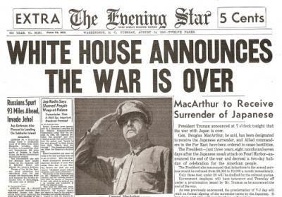

http://accountsoftheholocaust.org/accountsoftheholocaust/media/Avatars/yehoshua-buchler.png?ext=.pngYEHOSHUA BÜCHLER

There was incredible rejoicing. 

http://accountsoftheholocaust.org/accountsoftheholocaust/media/Avatars/ruth-cardin.jpg?ext=.jpgRUTH CARDIN

*Paris was liberated in August last year (1944) and we celebrated by filling the streets and heading to the Champs-Élysées to watch the American troops marching past and wave American flags! It was an amazing sight and an amzing feeling.*  
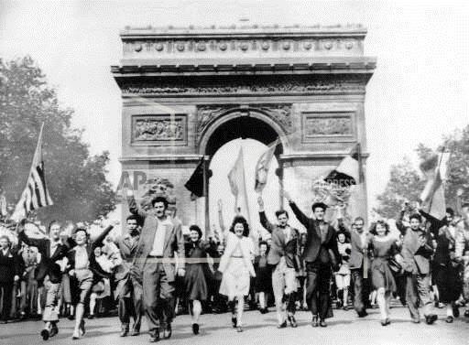

http://accountsoftheholocaust.org/accountsoftheholocaust/media/Avatars/arye-falk.png?ext=.pngARYE FALK (liberated from Buchenwald)

I remember a happy incident that took place after the Germans had fled from the camp. One   
of the inmates appeared holding a picture of Hitler, a picture in a glass frame. He hurled it to the ground and the sound of breaking glass was mixed with the cheers of the inmates.

http://accountsoftheholocaust.org/accountsoftheholocaust/media/Avatars/female-icon.png?ext=.pngFAY LEWIN

The Russian Army soon arrived and opened the gates.  They told us we were free but we should wait for the next wave of soldiers, as this wave was just the lead, making sure the path was clear.  The next wave brought food and water for us. The Russians told us to eat very little or else we would die, since we were so weak and malnourished.  People who ate a lot died right away. The Russians took us to a farm with plenty of food.

http://accountsoftheholocaust.org/accountsoftheholocaust/media/Avatars/miriam-akavia.png?ext=.pngMIRIAM AKAVIA

The war is over! Now? What for? It is no longer possible to live, there’s nothing anymore. Where were they before? What’s the use of it now?

http://accountsoftheholocaust.org/accountsoftheholocaust/media/Avatars/ruth-cardin.jpg?ext=.jpgRUTH CARDIN

I know that there are so many families who have been separated and that thousands are desperately looking for homes that have been destroyed and loved ones that are missing. But you are free! You are alive! You survived!

http://accountsoftheholocaust.org/accountsoftheholocaust/media/Avatars/yehoshua-buchler.png?ext=.pngYEHOSHUA BÜCHLER

But the Americans were not so happy. A Military Police jeep pulled up and asked who in the world we were – they wanted nothing to do with us. There was a Czech boy who knew English. He told them that we were inmates from Buchenwald, that we had escaped. They were afraid: They already knew and had heard that the camp inmates had all kinds of infectious diseases. So they kept their distance from us... they simply kept their distance and said: “Wait here”.

http://accountsoftheholocaust.org/accountsoftheholocaust/media/Avatars/rita-weiss.jpg?ext=.jpgRITA WEISS

 I always say it came too late. I don’t know how to be happy anymore. I am not happy and don’t feel like this life was worth living.

http://accountsoftheholocaust.org/accountsoftheholocaust/media/Avatars/haddasah-bimko.jpg?ext=.jpgHADASSAH BIMKO (survivor of Bergen-Belsen)

We have lost our families, our homes. We have no place to go, nobody who is waiting for us anywhere. We are liberated from death and from the fear of death, but we are not free from the fear of life.

http://accountsoftheholocaust.org/accountsoftheholocaust/media/Avatars/helen-lehman.jpg?ext=.jpgHELEN LEHMAN (Pułtusk, Poland)

What did we survive for? We have nothing. We have nobody… We are completely lost to the world.

http://accountsoftheholocaust.org/accountsoftheholocaust/media/Avatars/yitzhak-zuckerman.jpg?ext=.jpgYITZHAK (ANTEK) ZUCKERMAN

How could we be happy? I was completely broken! You'd kept yourself going all the terrible and bitter years, and now... we were overcome by weakness. Now we could suddenly allow ourselves to be weak… Ultimately there is an end to war. We had lived all that time with a certain sense of mission, but now? It was over! What for? What for?

* http://accountsoftheholocaust.org/accountsoftheholocaust/media/Avatars/robert-katz.jpg?ext=.jpgROBERT KATZ

*Ok, I think I am getting a better understanding of the challenges that you’re facing – where do you even start trying to re-build your lives? What is the first thing you did when you realized you were free?*

http://accountsoftheholocaust.org/getmedia/2f494075-9fca-46eb-b207-9c2bce0de45b/elie-wiesel.png.aspx?width=47&height=50&ext=.pngELIE WIESEL (liberated from Buchenwald on April 10)

Our first act as free men was to throw ourselves onto the provisions. That’s all we thought about. No thought of revenge, or of our parents. Only of bread

http://accountsoftheholocaust.org/accountsoftheholocaust/media/Avatars/rick-carrier.png?ext=.pngRICK CARRIER

They started giving out chocolate and they didn’t know at the time but two took the chocolate and ate it, took 3 steps and fell dead... they couldn’t take it.  Within minutes nurses and doctors came in and said “you can’t feed these people that” and they started to take them and clean them up.

http://accountsoftheholocaust.org/accountsoftheholocaust/media/Avatars/bella-jakubowicz-tovey.gif?ext=.gifBELLA JAKUBOWICZ TOVEY

I want you to know that when the war ended… I weighed the equivilent of probably what is 70 lbs , and I was skin and bone. And I do remember that when that British soldier came and asked me… Can he do anything for me? And I said to him “ I’d like two things I’d like him to give me… bring me warm socks. We’re talking, this was already May. It was warm. I was cold I wanted warm socks, knee length socks. And I wanted sugar… He brought me socks and I do remember two things. I put on the socks, and I started to cry because I didn’t have any calf, I was all bones… The knee length socks wouldn’t stay on. But I also remember that when he gave me the sugar, and it may not have been more than a quarter of a pound maybe… I took that bag and I just poured it into my mouth. I just ate it like that and… he got scared, and he ran out looking for the nurses because he thought god knows what I did to myself eating all that sugar. And I remember the nurse said to him in German that it’s okay, that I was just craving sugar.

http://accountsoftheholocaust.org/accountsoftheholocaust/media/Avatars/female-icon.png?ext=.pngFAY LEWIN

I weighed about 80 pounds, my gums had receded away from my teeth, and I was infested with lice so badly that they were living in my hair and body.  The death march had started with thousands, maybe 70 remained and were liberated, and some of those died upon liberation.

* http://accountsoftheholocaust.org/accountsoftheholocaust/media/Avatars/robert-katz.jpg?ext=.jpgROBERT KATZ

*Lately I have been reading the most horrendous newspaper reports on what was found when concentration camps were liberated. The photographs published are like scenes from hell – I can hardly believe they are real? For example – look at this Daily Mirror back page reporting on the liberation of the* [*Bergen-Belsen Concentration Camp*](https://encyclopedia.ushmm.org/content/en/article/bergen-belsen) *in 1945:*  
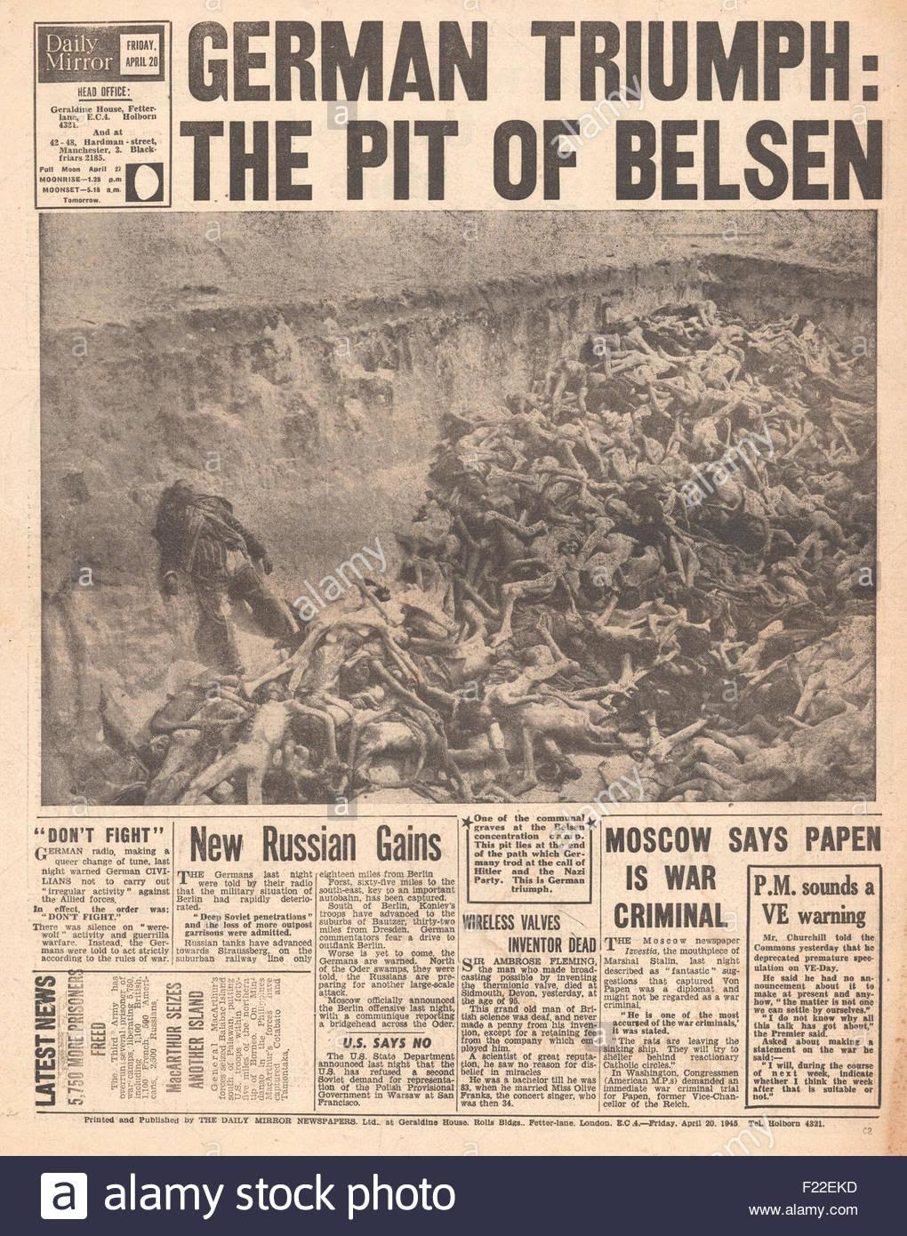

http://accountsoftheholocaust.org/accountsoftheholocaust/media/Avatars/general-dwight-d-eisenhower.jpg?ext=.jpgGENERAL DWIGHT D. EISENHOWER

We continue to uncover German concentration camps for political prisoners in which conditions of indescribable horror prevail. I have visited one of these myself and I assure you that whatever has been printed on them to date has been an understatement.

http://accountsoftheholocaust.org/accountsoftheholocaust/media/Avatars/leon-bass.jpg?ext=.jpgLEON BASS (Sergeant in the US army, detailed to help liberate Buchenwald)

I can never forget that day, because when I walked through that gate, I saw in front of me what I call the walking dead. I saw human beings that had been beaten, starved, tortured, they had been denied everything. They had skeletal faces, deep set eyes; their heads had been clean shaved. They were standing there, holding on to one another, just to keep them from falling.

http://accountsoftheholocaust.org/accountsoftheholocaust/media/Avatars/edward-murrow.jpg?ext=.jpgEDWARD MURROW (American journalist at the liberation of Buchenwald):

The clothing was piled in a heap against the wall. It appeared that most of the men and boys had died of starvation. They had not been executed, but the manner of death seemed unimportant. Murder had been done at Buchenwald.

http://accountsoftheholocaust.org/accountsoftheholocaust/media/Avatars/leon-bass.jpg?ext=.jpgLEON BASS

I saw the clothing of little children; the little children that didn’t survive. Up against the wall there were mounds of clothing. I saw caps, sweaters, stockings, shoes, but I never saw a child.

http://accountsoftheholocaust.org/accountsoftheholocaust/media/Avatars/albin-irzyk.jpg?ext=.jpgALBIN IRZYK (US army liberator of Buchenwald)

I had seen men in my tanks burn to death. I had seen the medics come in with casualties. But killing in combat is part of war. To see this, and recognize humans did it to other human…  it was extermination

http://accountsoftheholocaust.org/accountsoftheholocaust/media/Avatars/rick-carrier.png?ext=.pngRICK CARRIER

I saw the opening of Buchenwald… When you see something like this there is no way to be prepared for it… when you see it and smell it and feel it… the absolute depravity of what the Nazis did to them – you cannot believe for a minute that anyone would survive it – because they were living skeletons… I felt that their willingness to live was stronger than their willingness to let them die.