2022-2023 Calendar of Activities  September 16, 2022  Back to Shul night  The Men’s Club will BBQ for the congregation and welcome members back for the new year  September 18, 2022  Marlboro Day  The Men’s Club will build the Sukkah for the township’s annual Marlboro Day celebration at the Recreation center  October 9, 2022  Sukkah Building  Help us to build the MJC Sukkahs at both the Main and Chai Buildings, as well as the Rabbi’s house  October 13, 2022  18th Annual “Sports Bar in the Sukkah!”  Football and Baseball too! This is our annual paid-up Membership event; please make sure to join us. Food, drinks, football & good times  October 20, 2022  Steak and Scotch dinner  Our famous steak (or fish!) and scotch dinner is back with our new caterer and promises to be better than ever. See our flyer in the temple e-mails or contact Jeff Katz at jeffkatz@optonline.net to RSVP |  | October 30, 2022  Bike ride  Join us for a casual ~15 mile bike ride  November 27, 2022  Thanksgiving Food Drive  Bring leftovers to the Main Building for pick up and distribution to those in need  December 11, 2022  Northern NJ Man of the Year Dinner  Join us as we honor our Man and Youth of the Year at Congregation B’nai Tikvah in North Brunswick  December 2022  Hanukkah party  Join the Men’s’ Club as we cook latkes for the Hebrew school Hanukkah party  January 2023  NFL Playoffs Sports Bar  Food and good times watching the final game before the Super Bowl  February 2023  Build-a-Pair  We build Tefillin with our 6th graders  in preparation for the World Wide Wrap  February 12, 2023  “World Wide Wrap”  Join us and Jews from around the world on Super Bowl Sunday to wrap Tefillin and do this mitzvah |  | Spring 2023  Men’s Club Shabbat  Shabbat loaded with spirit and Ruach!  March 2023  Build a Grogger  We build Groggers with our 4th graders to help them celebrate Purim!  March 6, 2023  “Pour”-im– our Torch Award winning event  Purim is a lot more fun with members of  Men’s Club. Join for a pour of spirits as we hear the Megillah on Purim  March/April 2023  Yellow Candle Project – Yom HaShoah  Candle packing and delivery of the award winning Yellow Candle program to commemorate Yom Ha’Shoah  Plus we have more in the works:  * Speaker breakfasts  * Softball games  * Manasquan Minyan  * Silverball museum  * Pedal boat/canoe family outing  * Hearing Men’s Voices programs  Watch the temple emails and publications for times, location, additions & changes to any programming.
MJC Men’s Club  2022 Application  Name: _________________  Address: _______________  ______________________  Home Tel: _____________  Cell:__________________  E-mail:________________  Send this form and  $36 check payable to “MJC Men’s Club”  or by PayPal at mjcnjmc@gmail.com  Marlboro Jewish Center Men’s Club  103 School Road West  Marlboro, NJ 07746 | Show up for Shabbat and Sunday morning minyan – Please join Men’s Club for services on Saturday morning when there is not a B’nai Mitzvah planned and every Sunday morning.  Do you need some help around your home and don't know where to turn? Please contact us at Haimisha Helper - we are here and ready to lend a hand. If you have a small job such as replacing a light bulb, changing dead batteries, moving your patio furniture, schlepping boxes to the curb or some other need, MJC Men's Club is at the ready. We have a minyan of Men who want to help to make your life easier. Whether your need is short term or long, we are just a phone call away. Please call Jay Seliber at 908-581-2759 or email us at mjcnjmc@gmail.com. This is a free service provided by the MJC Men's Club. |  | 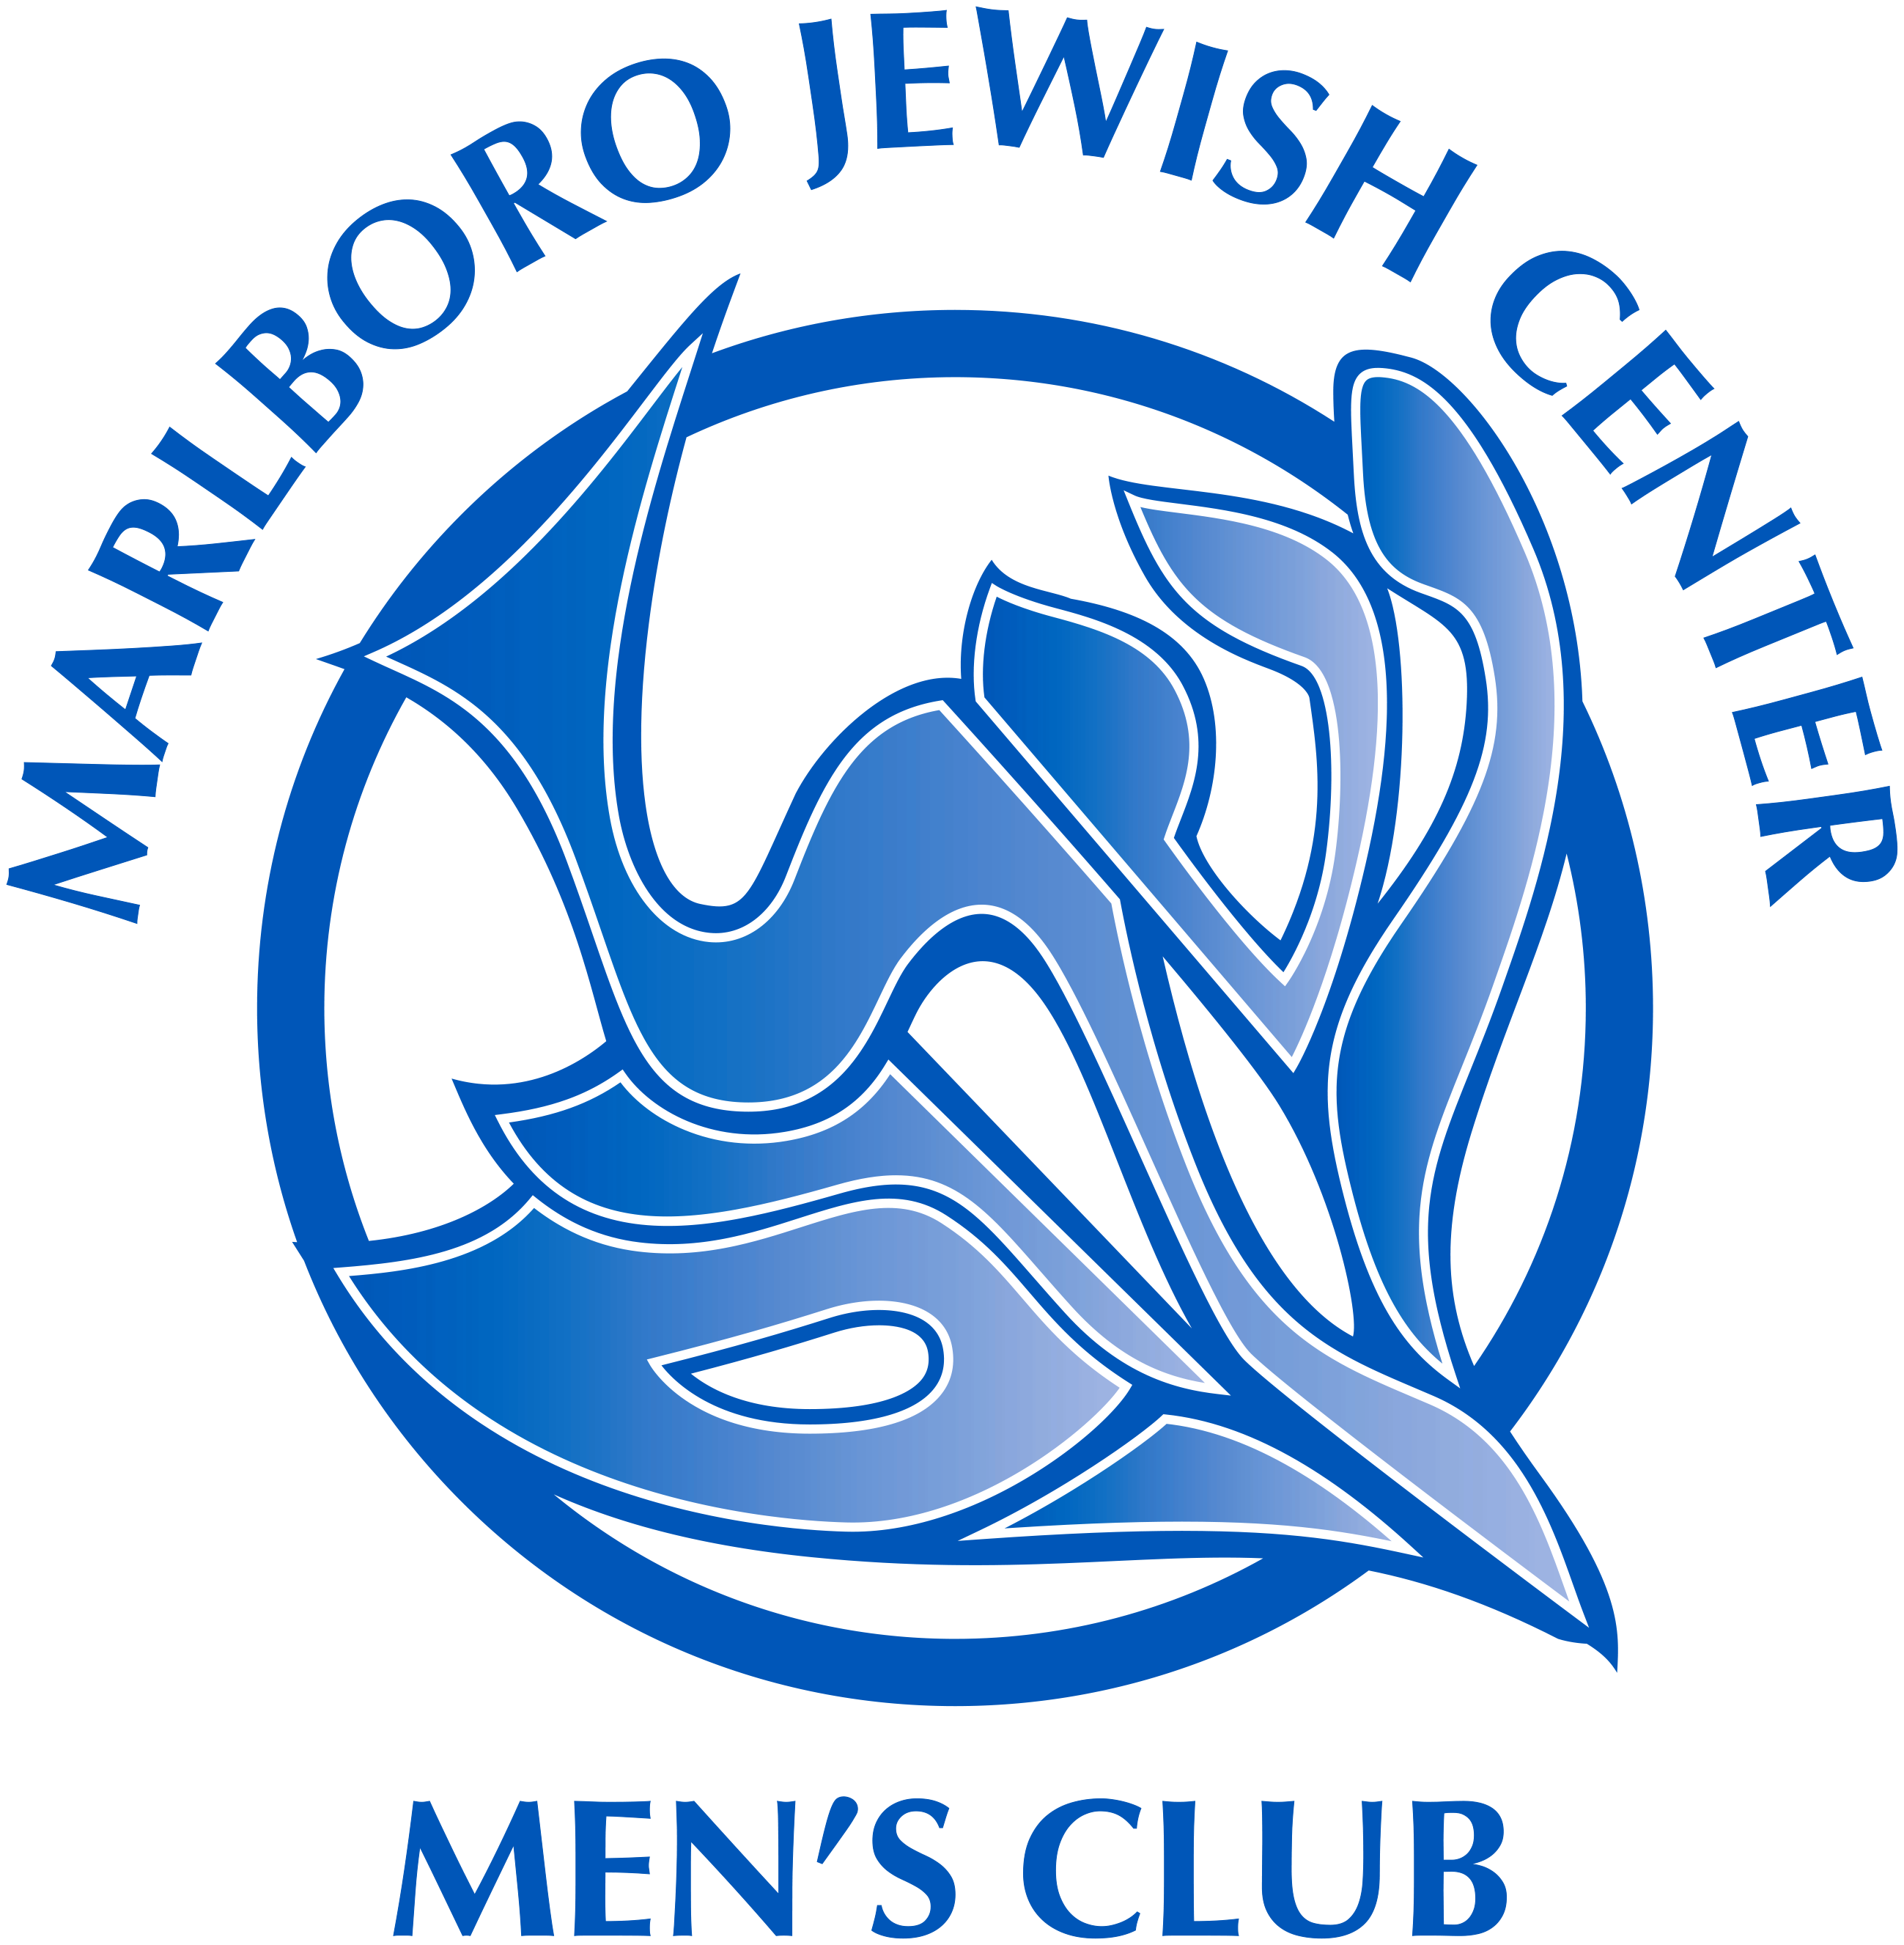  2022-2023 Schedule and Enrollment Form  Open to all men  Affiliated with  Federation of Jewish Men’s Clubs  A social and service arm of  Marlboro Jewish Center  President:  Jay Seliber  908-581-2759  mjcnjmc@gmail.com

