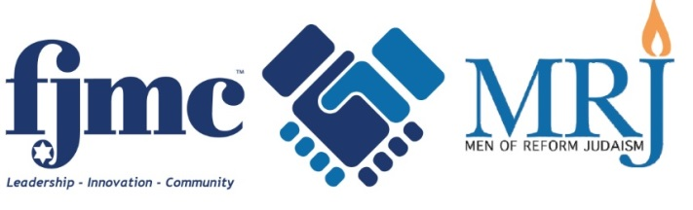

March 22, 2018

Shalom!

Enclosed you will find a Shoah Yellow Candle™. Please join with people around the world on Yom HaShoah, and light this candle on **Wednesday evening, April 11th**, in memory of the victims of the Holocaust. We do this for those whose entire families and towns perished in the Shoah, and for whom no one is left to light a Yahrzeit remembrance candle. “Light a Candle, Preserve a Memory”.

The act of kindling this flame and reading the enclosed meditation can be a moving ritual to remind us of what happened to the Jewish people not long ago. Place the candle in your window on Yom HaShoah to remind your community. This is also an appropriate time to discuss the Holocaust with your family.

The Yellow Candle program is a project of FJMC, in cooperation with the United Synagogue of Conservative Judaism and the Men of Reformed Judaism. We hope that the lighting of a Yellow Candle on Yom HaShoah will become an annual event in your home.

The number 18 is *chai*, or life. By remembering, by doing our part to ensure our future, we celebrate the ongoing life of our people even as we memorialize those who were destroyed. We appreciate your support of this Shoah project and of our on-going educational programs.

Please consider making a donation to the FJMC to help defray the costs of this program and to fund Holocaust education. Gifts in multiples of $18 are suggested.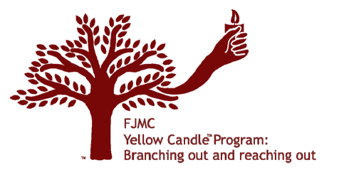 If your Men’s Club or Brotherhood would like to learn more about the Yellow Candle program, please contact me at blake.lenett@verizon.net.

Sincerely,   
  
*Blake Lenett*

*FJMC Florida Region - Vice President*

**- - - - - - - - - - - - - - - - - - - - - - - - - - - - - - - - - - - - - - - - - - - - - - - - - - - - - - - - - - - - - - - - - - - - - - - - - - - - - - -**

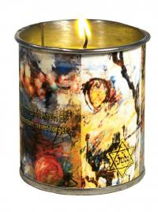

Thank you for your tax-deductible donation to the 2018 Yellow Candle program.

Amount enclosed: $18_____ $36_____ $54_____ $72______ (Other) _______

Please make checks payable to **FJMC Florida Region**

*Return this form with your donation to:*

*Blake Lenett*

*c/o Congregation Beth Shalom*

*1325 S. Belcher Road*

*Clearwater, FL 33764*

# Yom Hashoah Yellow Candle TM Meditations

Please light the Yom Hashoah Yellow Candle TM on the evening of Wednesday, April 11, 2018.

Recite one of the following meditations as you light it.

## Image result for shoah yellow candleAs I light this Yellow Candle, I vow never to forget the lives

of the Jewish men, women, and children who are symbolized

by this flame. They were tortured and brutalized by human

beings who acted like beasts; their lives were taken in cruelty.

May we be inspired to learn more about our Six Million

brothers and sisters as individuals and as communities, to

recall their memory throughout the year, so that they will not

suffer a double death. May we recall not only the terror of

their deaths, but also the splendor of their lives. May the

memory of their lives inspire us to hallow our own lives and to

live meaningful Jewish lives so that we may help to insure

that part of who they were shall endure always.

Written by Rabbi Jules Harlow

“Who Am I To Speak Of A Time?”

Who am I to speak of a time

of families crushed, of crimes of mankind,

of children in hiding and living in fear,

of mothers trying to hide all their tears,

of fathers praying to an empty heaven,

of people dying again and again?

Who am I to know what it was like

to be persecuted by day and trapped by the night,

to be surrounded by a world turned upside down,

to be starved and tortured and beaten to the ground,

to witness a nation of hate marching past,

to see all their dreams broken and shattered like glass?

Who am I to mention their suffering and pain,

the ghettos, the camps, life and death inhumane?

I wasn’t even born, I wasn’t even there,

it happened long ago, it could never happen here.

Who am I to know what God had in mind

when the virtues of man were buried alive,

when good lost to evil and hope turned to despair,

when hell upon earth seemed everywhere?

Who am I to let their memories be forgotten,

to say and do nothing as if it never happened,

to forsake the loss of our Jewish family,

to live in a world of complacency?

The Blessing of the Yellow Candle

We light this yellow candle to rekindle God’s flame,

To shine His light upon the world once again,

To sanctify the memories of the millions of souls,

To honor their prayers and all their lost goals.

We bless their existence by being alive

To light this yellow candle as proof we survived.

Ron Adler

Congregation Valley Beth Shalom Men’s Club

Encino, CA

