**FROM YOUR MEN`S CLUB**

**Below Except From;**

**Title;**

**By;**

**There is very little to do for this. Each month, we do an internet search looking for timely Jewish themed recycling articles. On this template, we include an excerpt with the source acknowledged. It is then submitted to our synagogue monthly bulletin and posted on the Facebook pages. It usually takes about 30 minutes to create. It is a very easy 1 man job. We remind our Men`s Club members at every meeting (monthly) about our clubs commitment to Shomrei Ha aretz and to support this** **program. We have raised over $200 for our club to date. Reporting the success of this easy fundraiser encourages participation for congregants to take a few minutes to drop off their recyclables and help our club and the environment.**

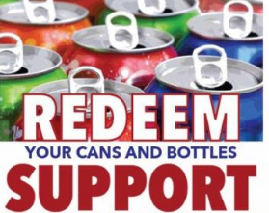

In the spirit of recycle-please support our MEN`S CLUB. Just drop off your redeemable bottles and cans at the **CAN IN CASH OUT Bottle Redemption Center**, during normal business hours and tell them it is for Nanuet Hebrew Center Men`s Club.

