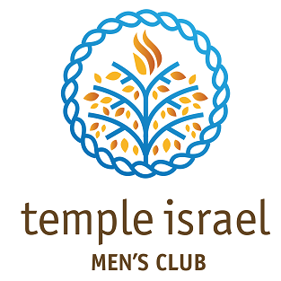
Charlotte, NC

To: FJMC Quality Club Award Review Committee
From: Mike Eisner, President
Date: April 30, 2021
Re: Quality Club Award Application

Gentlemen,
We have fulfilled Mandatory Requirement #2 this year by distributing FJMC Shoah yellow candles to all Men’s Club members as part of our Men’s Club Shabbat gift bag home delivery project. We also delivered candles to non-Men’s Club congregants who requested one. We still have enough inventory for next year.
In addition, we are prohibited by our new congregational privacy policy from distributing members’ e-mail addresses to outside groups. For next year our congregation is implementing an opt-in option for sharing personal information with groups like Federation, FJMC, Women’s League, etc.
We have paid dues, and I believe we have sent names, but we are unable to send a full list of e-mail addresses. Please let me know if this precludes our winning a Quality Club Award.
Thanks,
