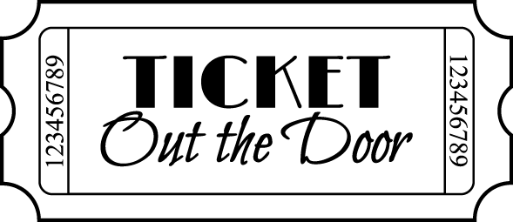

***Please circle the appropriate answer using the following scale:***

***1 = Poor 2 = Not so Good 3 = Average 4 = Very Good 5 = Excellent***

1) How would you rate this program?

1 2 3 4 5

2) To what degree did you feel like you had a chance to share your input?

1 2 3 4 5

3) To what degree did you feel the meeting met your expectations?

1 2 3 4 5

4) Did you learn something new at this meeting? Yes No

5) What did you like best about this meeting?

6) What did you like least about this meeting?

Thank you for your input. Let’s work together toward continued improvement.

Name (optional): Date: