**CBS DELI-NITE Party “2020 Style”**

**SUNDAY November 8th**

Enjoy Food, Fun, Friends and Football

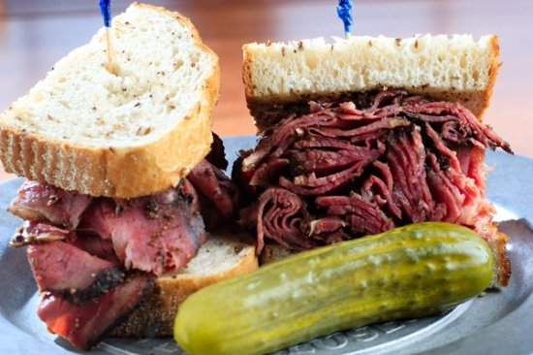

**Bucs vs. Saints Jo-Els / Dunedin Vegan Deli**

**Kosher Deli Dinner for two $65.00 and for one $32.50**

**½ lb. packs of deli, loaf of Jewish rye bread, coleslaw, NY potato knishes, Kosher dill pickles, Gulden’s spicy mustard, Russian dressing, desserts by Andi Szmiga**

**Featuring Soup from Rabbi David’s Kitchen for $10 each**

***Introducing for the first time ever!***

**From Dunedin Vegan Deli “Corned Beeph, Pastramy, Turky and Salamy” ____________________**

**Proceeds will benefit the CBS Technology** **Fund**

**Supporting our use of Zoom, Live Streaming and YouTube**

**Prepared for you by our CBS Brotherhood**

**For any questions or to volunteer, please call the office at 727-531-1418, contact** David **727-725-4889 or email:** [dsadowsky85@gmail.com](mailto:dsadowsky85@gmail.com)

**Food pick up at CBS-1325 S. Belcher Rd. from 3:00-5:00PM**