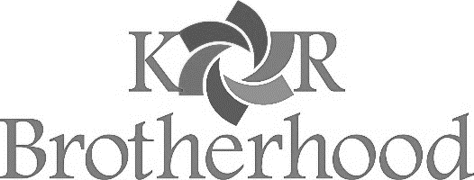
Dear Fellow Congregants,
Please accept this Leo Wolf Memorial Yellow Candle with the compliments of the Kol Rinah Brotherhood. We ask that you join us on Erev Yom HaShoah, the evening of April 7, by lighting the yellow candle, placing the candle in a prominent place and reciting the enclosed mediation. It is our collective obligation, as Kol Rinah and the worldwide Jewish community, to honor and remember the Six Million who perished in the Holocaust.
In the spirit of remembrance, we encourage all of you to give Tzedakah as a form of respect to those who did not survive the Holocaust. Please help us remember those who suffered in the Holocaust along with the memory of Leo Wolf by lighting this Yellow Candle with Kol Rinah, St. Louis and people around the world on Erev Yom HaShoah ‒ the day dedicated to remembering the Holocaust.
Thank you to those volunteering their time to help pack and deliver the Yellow Candles along with Mishloach Manot. Through your generosity we will continue to purchase and provide candles to our synagogue membership each and every year and to pledge our collective support to organizations dedicated to keeping the memory of the Six Million alive even as the number of survivors dwindles.
B’Shalom,
Bob
Bob Olshan
President

Enclosed is my Yom HaShoah Tzedakah donation to Leo Wolf Yellow Candle Program.
$36 $54 $72 $118 Other

Name

Address

Please send your check payable to Kol Rinah Men’s Club, in the enclosed envelope. Thank you for your generosity and support.

