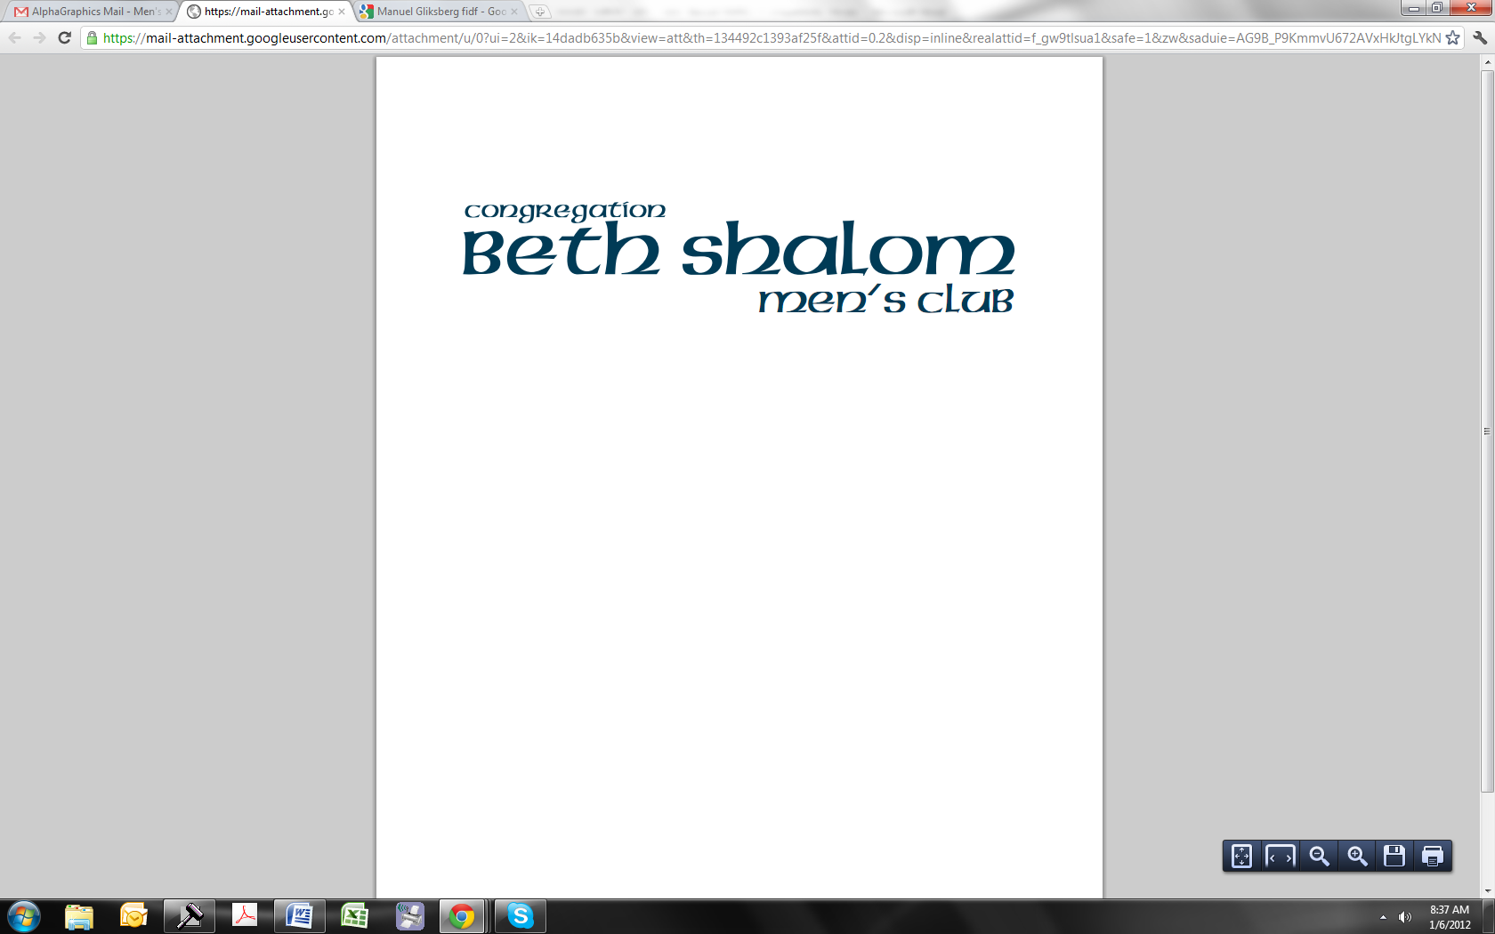

PRESENTS:
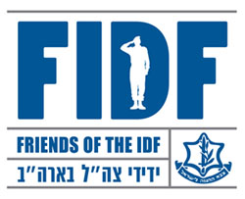
Sunday, January 29
9:30 a.m. (after minion)

Join us for breakfast on Sunday, January 29 at 9:30 (after minion) where Manuel Gliksberg will be speaking on behalf of FIDF. Manuel Gliksberg serves on the Board of Directors of Friends of the Israel Defense Forces and was a Lone Soldier, a Sergeant serving in the IDF. Manuel will speak about the organization and FIDF programming/ways to help support the soldiers, and speak firsthand about his experiences in the IDF.
This is in conjunction with our 9th annual Texas Hold’em tournament (held on the same day – Sunday, January 29) where the money raised this year will be donated to Friends of the Israel Defense Forces.
Friends of the Israel Defense Forces was established in 1981 by a group of Holocaust survivors to provide for the wellbeing of the men and women who serve in the Israel Defense Forces as well as the families of fallen soldiers.

The FIDF initiates and helps support social, educational, cultural and recreational programs and facilities for the young men and women soldiers of Israel who defend the Jewish homeland. The FIDF also provides support for the families of fallen soldiers.

For more information, contact Dan Sher at (847)948-5130 or dan@sher.com

