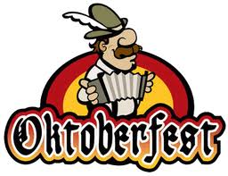
In The Sukkah
Eat, Drink and be Merry
Sample Beers, Kosher Knockwurst, Popcorn, Pretzels and More
Trivia Contests
Come and socialize with the Beth El Community
It’s a Mitzvah to eat in the Sukkah

Tuesday October 18th 6:00– 9:00PM
Beth El Temple Sukkah

Oktoberfest $10.00 Men’s Club Members $5.00
RSVP: Harley Graime at 860-582-9027 hgraime@att.net by Oct. 16th

