March, 2019 Change to appropriate date

Adar II 5779

Dear Kol Rinah Family,

I write to you to add my personal support and ask for yours for the *Yom HaShoah Yellow Candle Program* undertaken by our congregation’s Brotherhood in conjunction with the Federation of Jewish Men’s Clubs.

Lighting a memorial candle for Yom HaShoah, Holocaust Remembrance Day, is a modern mitzvah—a modern commandment that I feel deeply obligated to fulfill, and I hope you will take this modern mitzvah seriously. I am so grateful to our Brotherhood for enabling every household in our congregation to light a candle and fulfill this modern mitzvah.

Please light the candle after sundown on Wednesday evening,

April 7, 2021 and by doing so, take the time to remember the Six Million Jews who perished in the Holocaust.

L’shalom,

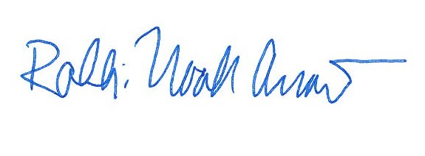

Rabbi Noah Arnow